Press release

More transparency and security for targeted action
Air quality measurements in the city of Ettlingen
Ettlingen/Karlsruhe, January 9th, 2023 +++ Making the invisible visible - under this motto, the city of Ettlingen, together with Stadtwerke Ettlingen and Palas GmbH from Karlsruhe, have started a pilot project to measure the current air quality values in the city at various locations and make the collected data available on the municipal homepage.

Five fine dust measuring devices have recently been installed at the city train station, at the gas station at Seehof, on the tower of Ettlingen's city hall, and on the roof of Ettlingen's public utility company. More are to follow in the city area and individual districts. The aim is to record the air quality at the various locations in order to obtain a better picture of possible health risks. With this project, the city of Ettlingen is taking an important step towards creating and maintaining a healthy and sustainable living environment. The collected particulate matter data is made available to the citizens on the website of the city of Ettlingen. Thus, all citizens of Ettlingen have the opportunity to reliably inform themselves about the actual air quality and, if necessary - as far as possible - to adjust their daily routine accordingly. They can be accessed at the following link: https://www.ettlingen.de/umweltsensoren.
Responsible for the project of the city of Ettlingen is head of the main office and digitalization officer Andreas Kraut with his interdepartmental project team. Stadtwerke Ettlingen GmbH as the city's infrastructure service provider with Florian Kraft took over the installation of the fine dust measuring devices from the AQ Guard Smart series. The latest member of the Palas® product family is a compact, cloud-enabled and MCERTS certified measuring device for determining air quality. In addition to the usual PM_{2.5} and PM₁₀ particulate matter values, the device also displays temperature, humidity and pressure as well as the pollutant gases SO₂, NO₂, CO and O₃ at sensitive, high-traffic locations.
In addition, Palas® is testing the integration of the environmental sensors into the city's existing, area-wide LoRaWAN network (Long Range Wide Area Network), because this transmission technology is increasingly used by municipalities in particular.
Easy implementation and integration for municipalities, precise and up-to-date measurement data for all
All devices installed in Ettlingen transmit data directly to Palas GmbH's cloud-based environmental measurement system "MyAtmosphere". In the future, the city of Ettlingen will receive the data via this system without detours and up-to-date on its website.
The optical particle analysis used is also used for the nationwide official measurement of fine dust. This technology determines the particulate matter values immediately without post-evaluation and correction, regardless of weather conditions or time of day.
The city of Ettlingen is thus consistently pursuing its path towards further digitization and transparency towards its citizens - another building block in its digitization strategy.
Mayor Johannes Arnold says: "We are pleased that we were able to install these devices in Ettlingen together with the company Palas and we are excited about the long-term evaluations." Andreas Kraut adds, "It is exciting to observe how the air quality changes over the course of the day - depending on the traffic situation, time of year, weather situation, temperature, etc."
Air pollution - underestimated risk
"With our technology, the city of Ettlingen is able to give its population more transparency and more safety. Air pollution is unfortunately not taken seriously enough yet it has a great impact on us and our environment" summarizes Henrik Hof, product manager of Palas GmbH.
Air pollution is the biggest environmental health risk in Europe. Every year, more than seven million people die as a result of air pollution, according to the WHO. 96% of the urban population was exposed to particulate matter concentrations above the new World Health Organization (WHO) guideline value of 5 µg/m³ (PM_{2.5}) in 2021.
The European Commission has set a 2030 target to reduce premature deaths from particulate matter by at least 55% compared to 2005. To this end, the EU's air quality directives are being revised and adapted to the WHO recommendations.
The Palas® solution - precision is what counts
Reliable measurement accuracy is therefore even more important than before in order to take appropriate measures to protect people and the environment. Palas® measuring instruments offer the necessary precision and reliability here. Using state-of-the-art optical measurement technology that measures optical light scattering from individual particles, Palas® measuring instruments count every single particle in the air. This guarantees precise measurement results and reliable data even at very low particle concentrations.
About Palas:
The Palas GmbH is a leading developer and manufacturer of high-precision devices for the generation, measurement and characterization of particles in the air. With numerous active patents Palas® develops technologically leading and certified fine dust and nanoparticle measuring devices, aerosol spectrometers, generators and sensors as well as associated systems and software solutions. Palas® was founded in 1983 and employs about 90 employees at the company headquarters in Karlsruhe.
Press Contact:
Palas GmbH
Sarah Kunath
Marketing & Corporate Communication
Phone: +49 721 96213 132
E-Mail: sarah.kunath@palas.de

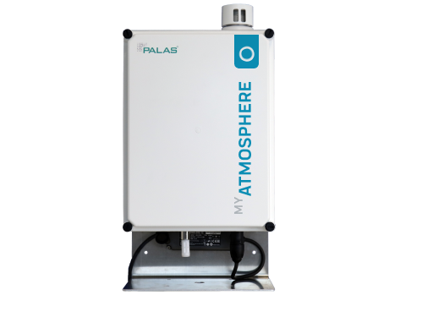
Picture 1: AQ Guard Smart System: Compact, precise, certified
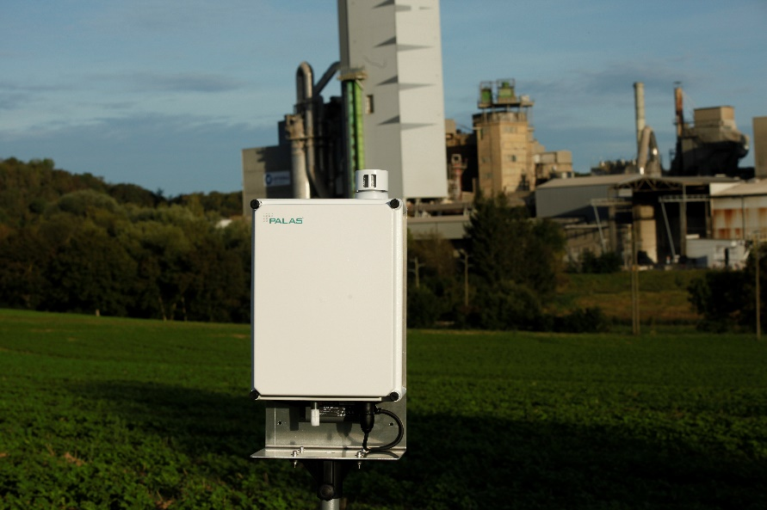
Picture 2: AQ Guard Smart System

